**­­­**

|  |  |  |
| --- | --- | --- |
| **North Seattle College**  **MyCollege.TIPS Administrator Guide** | | |
|  | Version: 1.0  Date: June 9th, 2017  Authors: Bonnie Peterson  Bryson Good  Jason Panzer  Kip Tatum  Lucas Schwarz  Michael Fraser  Mitch Thompson  Kenny Quach  Karen Petersen  Ilsa Coleman  Rasa Rasiulyte  Travis Karpinski |

**Q**

|  |  |
| --- | --- |
|  | **Document Revision History** |

|  |  |  |  |
| --- | --- | --- | --- |
| **Revision No.** | **Revision Date** | **Author** | **Description** |
| 1.0 | 06/06/2017 | M Fraser | Creation of document |
| 2.0 | 06/09/2017 | K. Petersen | Added all authors to title page  Added in TOC sections  Added Edit Tips Section |
|  |  |  |  |
|  |  |  |  |
|  |  |  |  |
|  |  |  |  |
|  |  |  |  |

|  |  |
| --- | --- |
| **Authorization and Sign-Off Memorandum** | |
|  |  |
| I have carefully read and assessed this North Seattle MyCollege.TIPS Developer Guide. This document reflects the practices and fulfills the requirements of the deliverable as a guide for the application create for North Seattle College... | |
| SIGN-OFF AND AUTHORIZATION: Please check the statement below that best reflects the current state of this document.  🞎 This document meets our standards.  🞎 The document is accepted pending the changes indicated.  🞎 The document does not meet the required standards. | |
|  | |
| NSC Committee Chair | Date |

**TABLE OF CONTENTS**

**1.** **Application Overview** 4

**1.1** **Login Verification** 4

**1.2** **Tips** 4

**1.2.1 Tips Submission** 4

**1.2.2 View Previous Tips** 4

**1.2.3 Contact Admin** 4

**1.3** **Tips Administration** 4

**1.3.1** **Reports** 4

**1.3.2 Admin Management** 4

**1.3.3 Tips Management** 4

**2.** **FAQ’s** 5

**3.** **Outstanding Issues/Future Enhancements** 6

|  |
| --- |
| **Application Overview** |

This application was created for North Seattle College to replace TIPS application built inside of Canvas.

## **Login Verification**

Login Verification…

## **Tips**

## **Tips Submission**

Tips submission…

## **View Previous Tips**

View Previous Tips …

## **Contact Admin**

Contact Admin…

## **Tips Administration**

## **Reports**

Reports…

## **Admin Management**

Admin Management…

## **Tips Management**

The Tips Management page is provided to enable the administrator to add, modify and inactivate questions and answer options.

The Tips Management home screen will display all questions in the database. Active questions will display first, and inactive questions will display at the bottom of the list. Each question will display buttons that will allow you to add a new question before or after the question you’ve selected, modify the question text and/or example text, move a question up or down in the list, which is how they will be displayed in the Tips Submission pages, inactivate/activate a question, and edit the answer list of a question that is of a dropdown list, radio button, or checkbox type.

Additionally, an Edit Division List is available to edit the Divisions listed on the first page of the Tips Submission page.

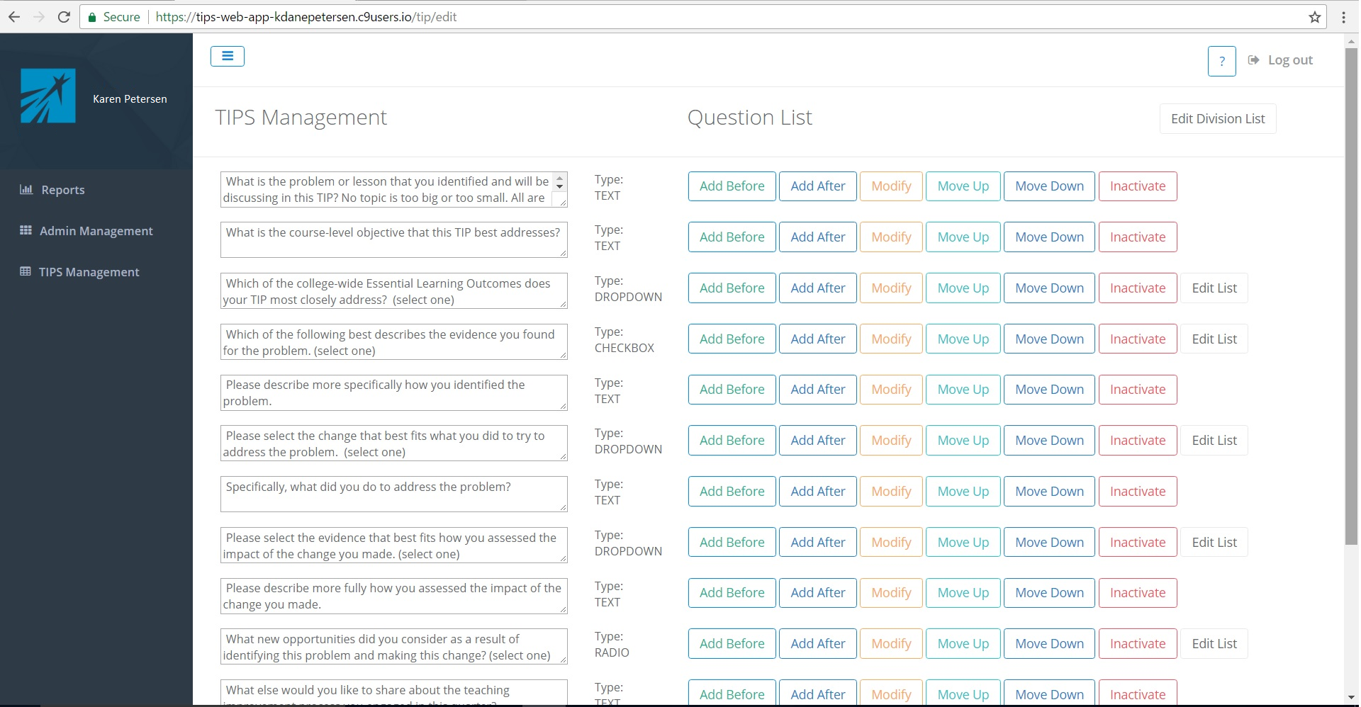

Selecting the Add Before or Add After button will display a modal that will allow you to add a new question. You can enter the question text, an example of an answer, and the type of answer entry field you want displayed on the Tips Submission form.

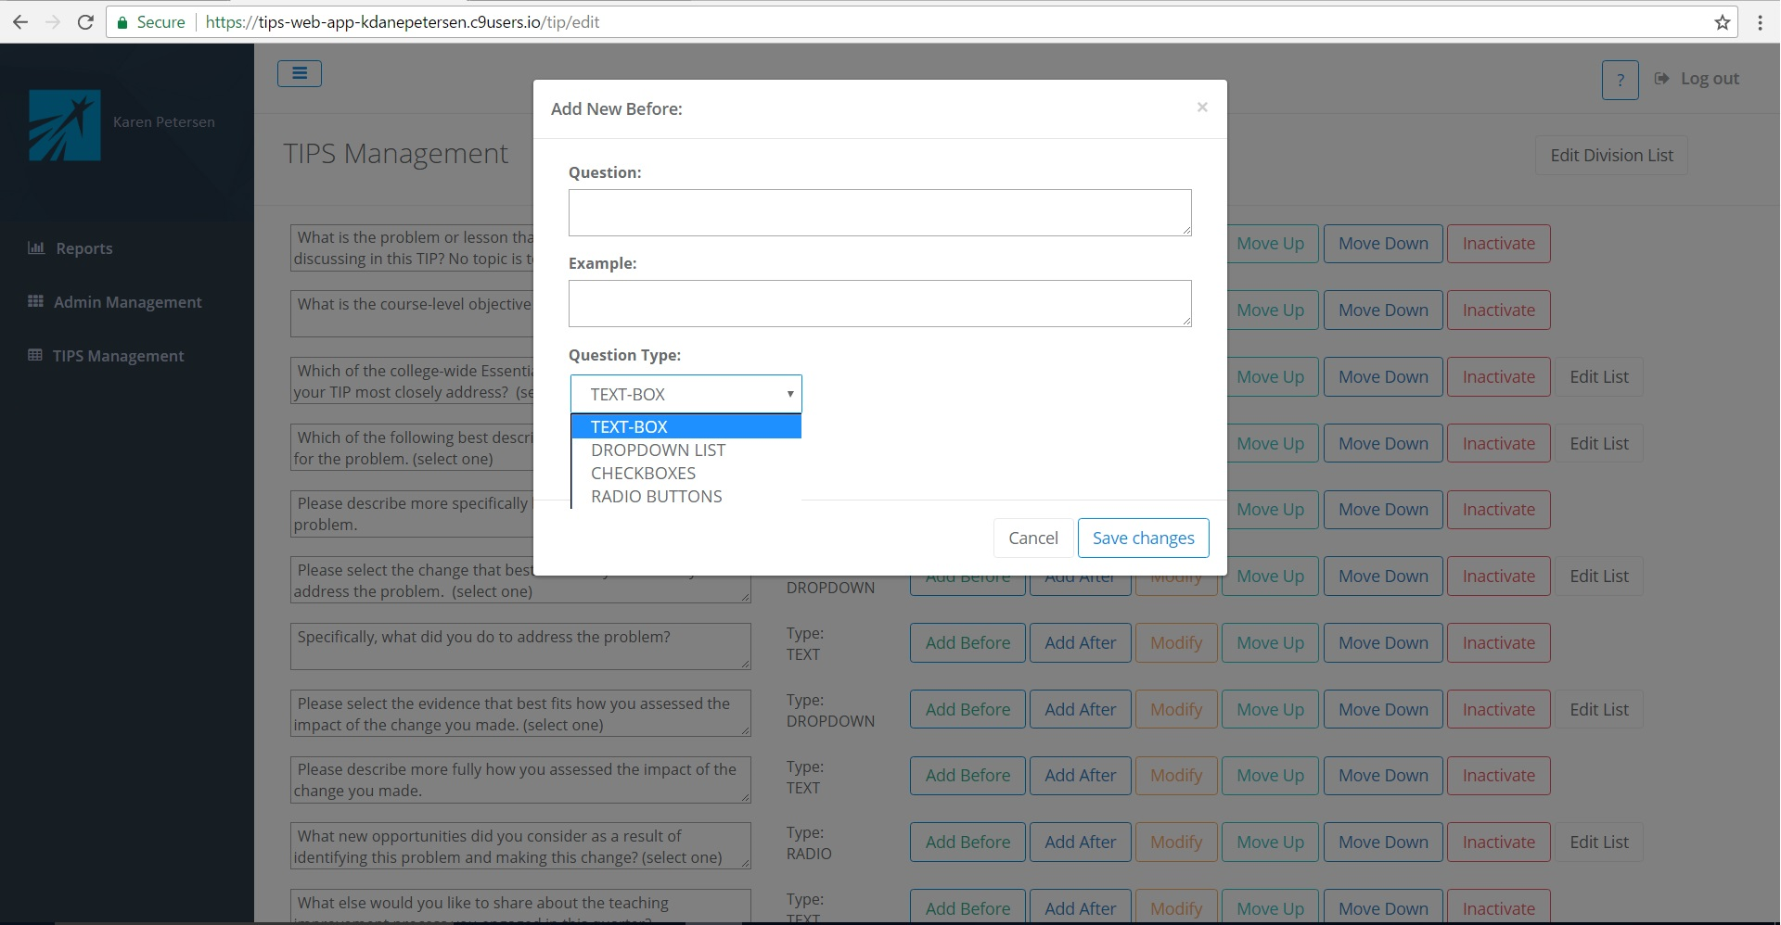

Selecting a Checkboxes or Ratio button answer type will pop up 6 text entry fields that will allow you to enter up to 6 answer options. Selecting a Dropdown question type will allow you to enter up to 15 answer options.

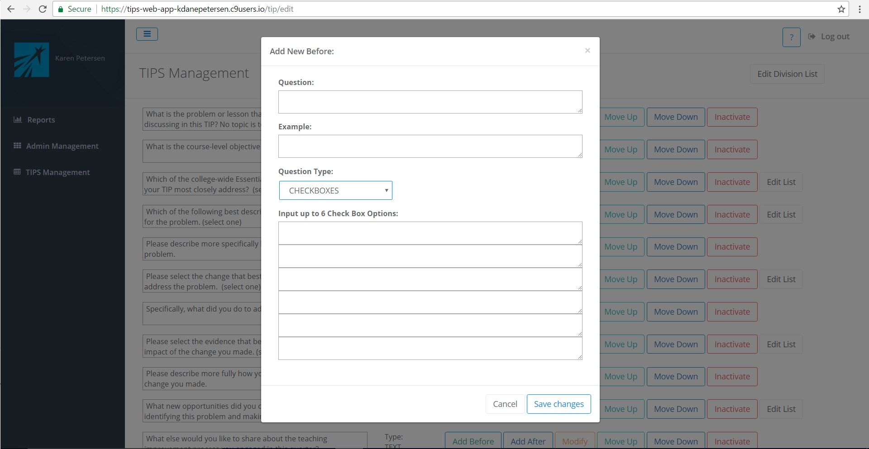

Selecting the Modify button will display a modal that will allow you to edit the question and/or description for an existing question

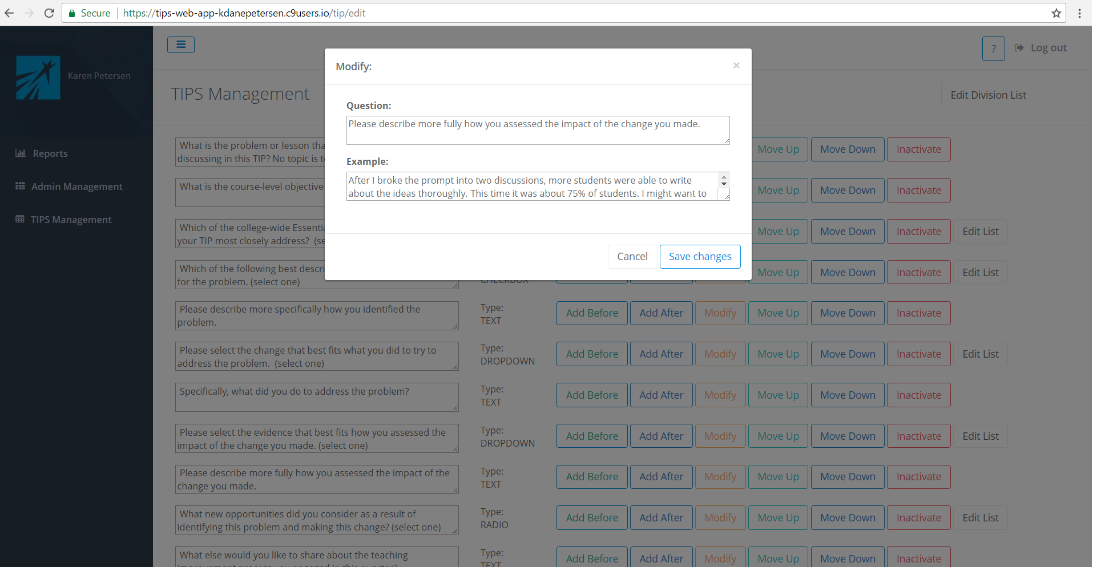**+**

The Edit List button will display of any question that has had a Checkboxes, Radio Buttons, or Dropdown List selected as it’s type. Selecting the Edit List button will display a modal that will allow you to add or delete answer options. Use the refresh key to correct any screen refreshing issues when adding a new answer option.

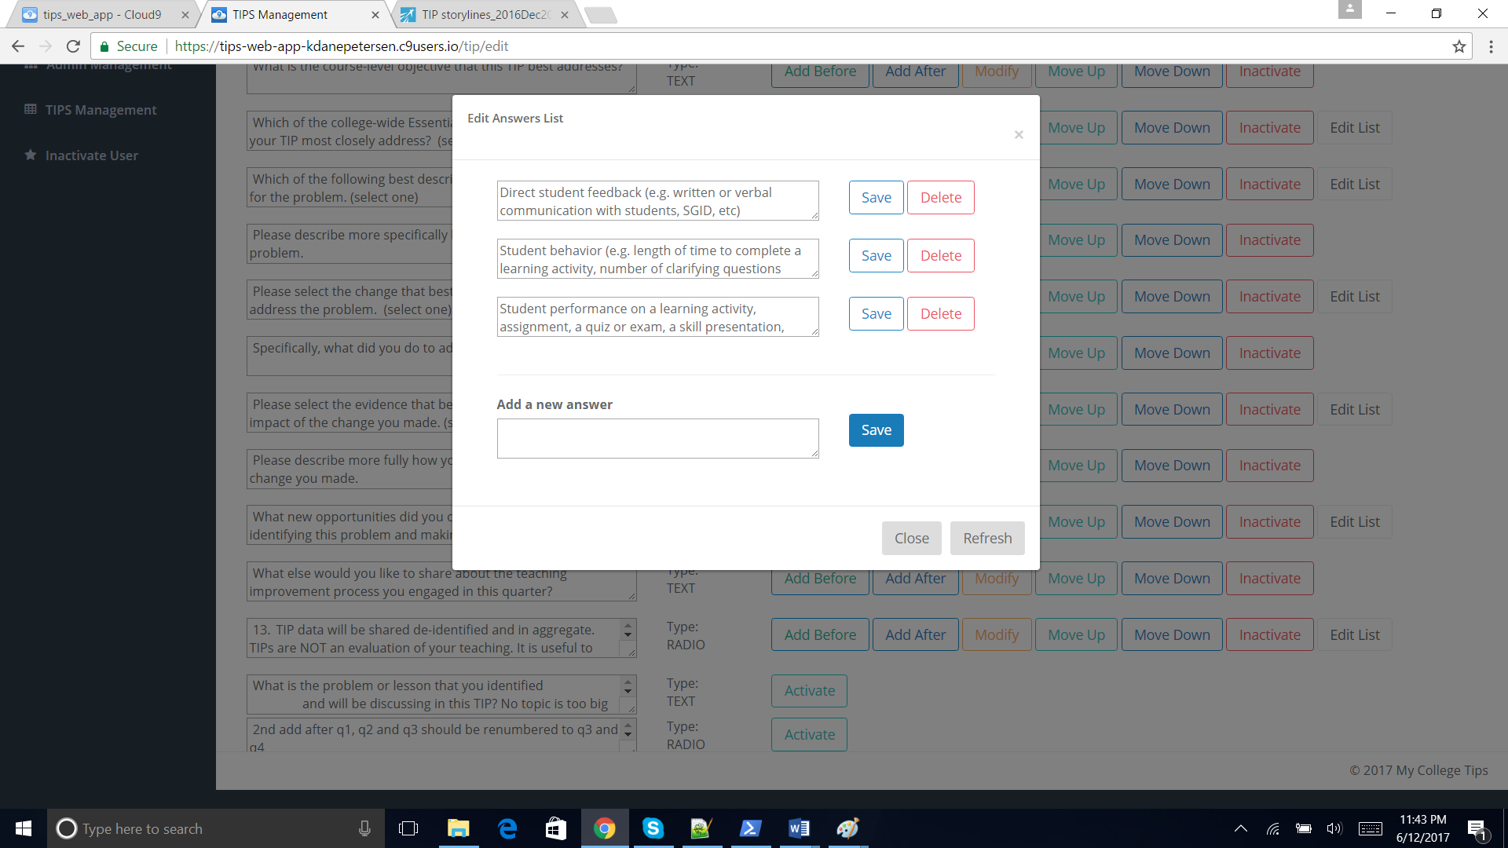

The Edit Division List in the upper right corner of the screen will display an edit modal where you can add, modify or delete division information.

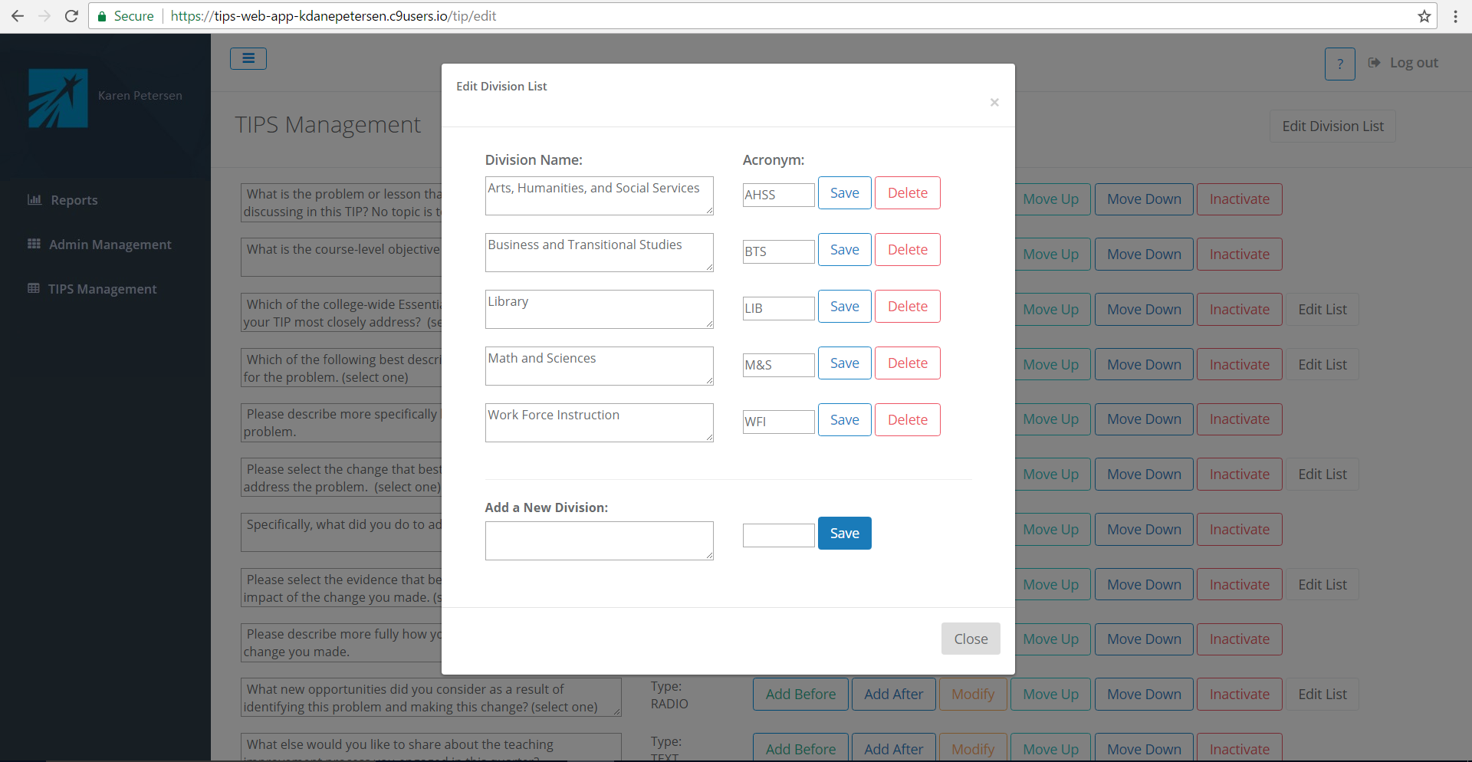

**2. FAQ’s**

1.

Q: In Tips Administration, when I add an answer to an answer list and press save, the answer doesn’t display in the list of answers. What is happening?

A: This is a connectivity/refresh issue. Click the refresh button and the answer should pop up on the screen. If the issue persists, exit out of the edit list screen, and click the edit list button to re-enter the screen, which should refresh the data.

2.

**3. Outstanding Issues / Future Enhancements**

Outstanding Issues

Future Enhancements

1. Add spell check to text entry fields for tip entry
2. Add spell check to text entry fields for tip management (add/modify questions, descriptions, lists)
3. Consider replacing tips management section to 3rd party survey library depending on licensing requirements and support.